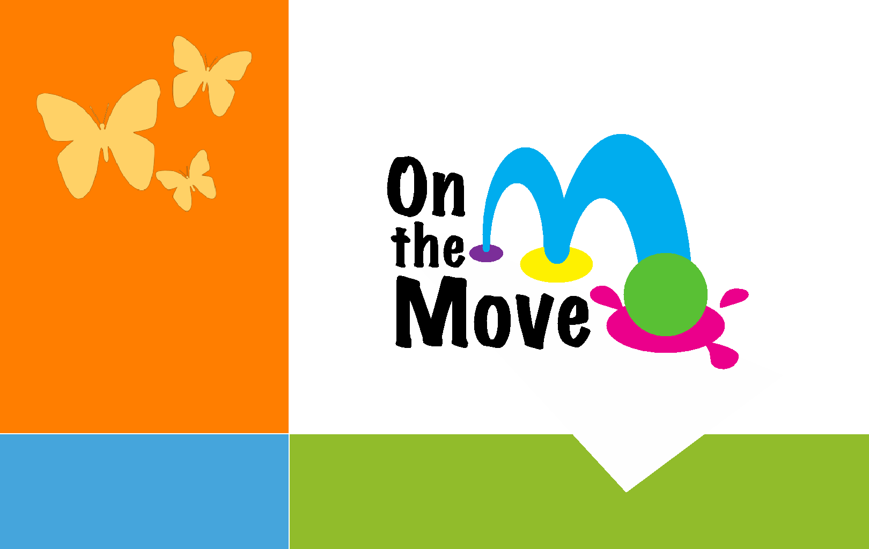
Welcome to

Email us:

Onthemovepreschool

@gmail.com

Our website:
⁶¹⁴⁻⁹⁴³⁻⁵⁹⁴⁰ onthemovepreschool.com

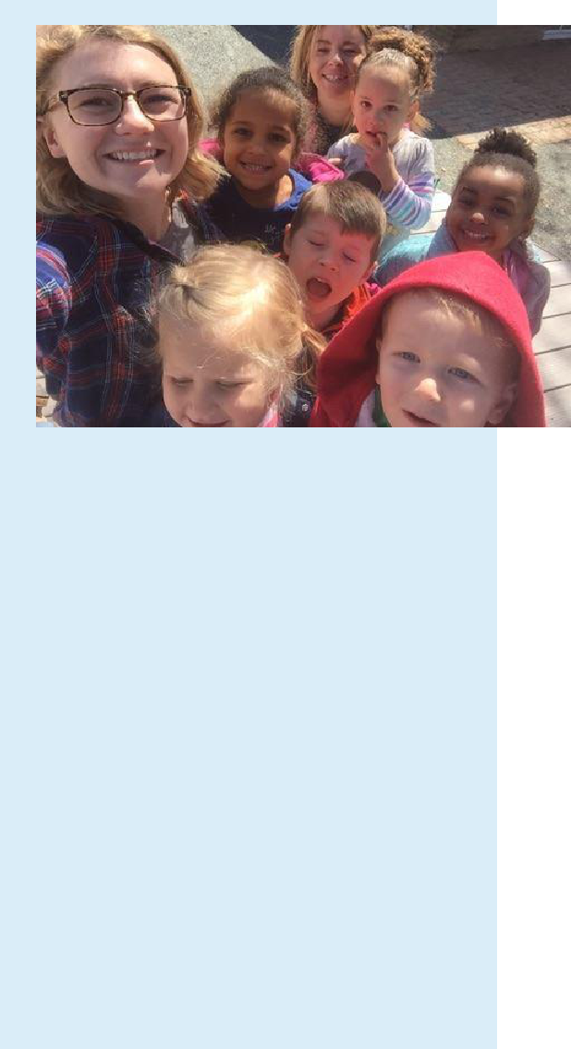

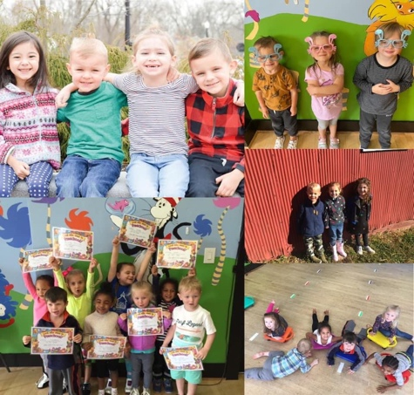

Find us at: On the Move Learning Center/onthemovelc
z

Thank you for enrolling in the On The Move Program! Mrs. Jade and Mrs. Ruth are looking forward to an exciting year! Our goal is to make learning not only fun, but something that every child aspires to do throughout life.

Snack: Please send your child with a snack and drink everyday (please no nuts).

Connect with us:

Brightwheel is a free, easy-to-use app for schools for attendance, parent communication, recording activities, photos, and much more!
- Choose a Check-in Code: If your provider is using Brightwheel's check-in system, you can set a custom 4-digit code in My Profile.
- Add Family or Approved Pick Ups: You can invite parents, family, and approved pickups within your child’s profile. For example, a nanny or friend who has your approval to pick up your child from school.

